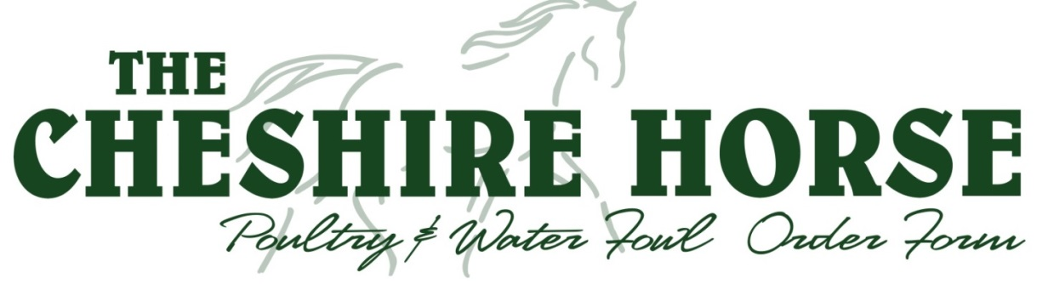

NAME: PHONE:

TODAY’S DATE:
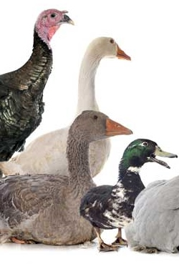
REMEMBER…
- Baby Birds will be available for pickup after 2:00 p.m. on the date that they arrive. The Cheshire Horse will call when the birds arrive. They must be picked up within 24 hours of their arrival.
- We cannot guarantee ship dates, and therefore arrival dates and availability are subject to change.

Please circle the week you would like your chicks, and indicate the quantity you would like to order:
SKU | BREED | SEX | QTY | Ship Week |  | PRICE
2918 | Assorted Color Indian Runner Duckling | Straight |  | 4/24 | 5/29 | $8.25
2919 | Blue Swedish Ducklings | Straight |  | 5/29 |  | $7.95
2933 | Buff Ducklings | Females |  | 4/24 |  | $9.00
3558 | Cayuga Duckling | Females |  | 4/24 | 5/29 | $9.00
2921 | Giant White Pekin Ducklings | Straight |  | 5/30 |  | $6.00
2939 | Gold Star Hybrid Ducklings | Females |  | 5/29 |  | $10.25
2905 | Khaki Campbell Ducklings | Females |  | 4/24 |  | $9.00
2936 | Rouen Ducklings | Straight |  | 4/26 |  | $7.50
2998 | Black/White Magpie Ducklings | Straight |  | 4/26 |  | $8.00
2999 | Black East India Ducklings | Straight |  | 4/26 |  | $8.00
3556 | Welsh Harlequin Ducklings | Straight |  | 4/24 |  | $10.00
2590 | Buff Gosling | Females |  | 5/29 |  | $35.00
3550 | Toulouse Gosling | Straight |  | 5/29 |  | $14.95
2951 | Broad Breasted White Turkey Poult | Straight |  | 5/30 |  | $6.25
2900 | French Gray Guinea Keet | Straight |  | 5/30 |  | $5.25
2950 | Mammoth Bonze Turkey Poult | Straight |  | 5/30 |  | $7.25

TOTAL BIRDS: TOTAL PRICE:

8 Whittemore Farm Rd, Swanzey, NH 03446 • 1-877-358-3001 • info@cheshirehorse.com
Open Mon-Thu 8:30-6:00, Fri 8:30-7:00, Sat 9:00-5:00, Sun 10:00-5:00

